1) Write an algorithm that describes how to make scrambled eggs, try to use control words, like IF, WHEN, UNTIL, WHILE, WAIT, AND, OR.

How to make scrambled eggs

* Get a bowl
* Get the eggs from the fridge
* Crack the eggs in the bowl
* Get a fork
* Stir eggs until it becomes battered
* Get the pan
* Spray the pan with cooking oil
* put the gas on under the pan until it heats up
* pour battered eggs on pan
* wait three minutes for battered eggs to cook
* flip eggs with spatula and wait two more minutes
* when done turn gas off
* pour cooked eggs into bowl
* wait till the eggs cool down
* eat it

2) Is Idle (the Python language shell) an Interpreter or an Compiler or both? Explain your answer.

Idle (the Python language shell) is both an Interpreter and a Compiler. Reason being is because a CPU only understands machine language instructions. So any instructions that are written must be translated into machine language. A compiler translates a high-level language program into machine language program. An interpreter executes and translates the algorithm/program into machine language and then the cpu executes the algorithm/program. Depending on the language that the program/algorithm was written in. Python will either use a compiler or an interpreter to translate the algorithm/program.

3) Write a command in the Idle shell that says “Hello world”

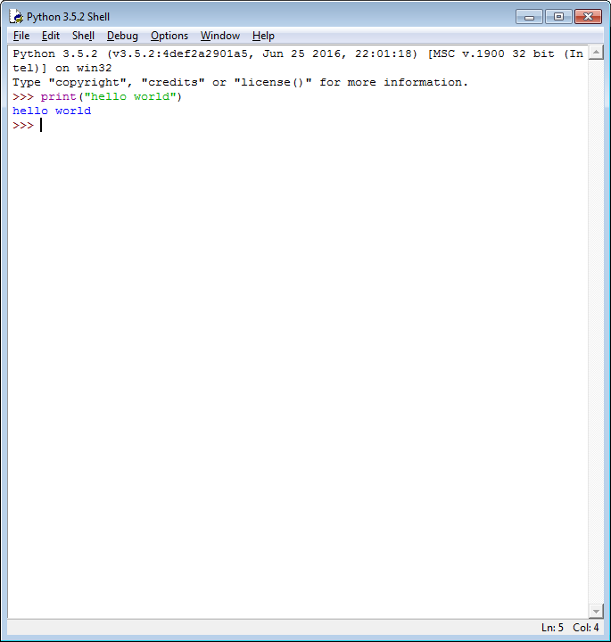

4) Write a program that produces the following output:

Hello World

I am in my ISD class right now

**Reminder on “Input”:**

A simple way to store variables (values) in your program is to use variables. Variables are placeholders that can store values, like strings (words), numbers (int) etc.

To create a variable, just give it a name and an initial value, for example for a number:

number = 7

or for a String (words):

myword = “This is my word”

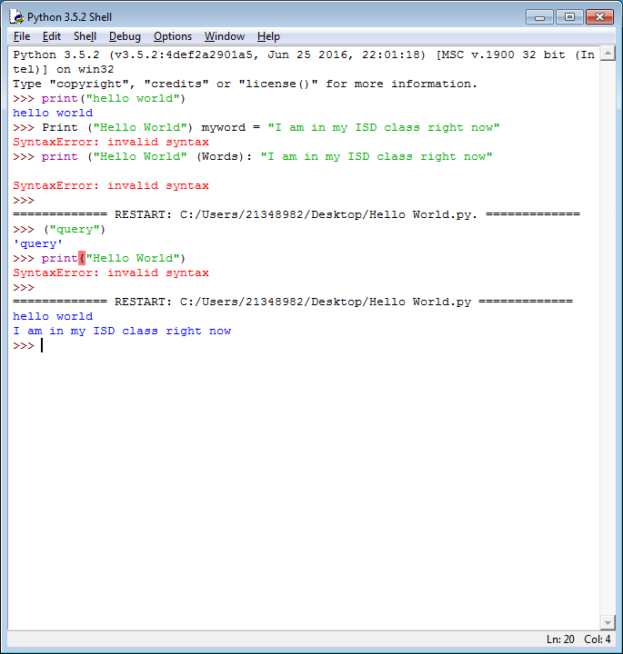

5) Write a program that asks the user for his/her name and produces an output like:

Hi there, what is your name?

>User input to be read<

Hello

“User name”

How are you?

